INDUSTRY PROBLEM-SOLVING TASK
Java AWT, Applets, Event Handling and Layout Managers

Name of the Student | NITHISH RAAJU V | Register No. | 192411016
Programme / Section | CO4-AT1 | Date | 23-08-2026
Course Code | CSA0925 | Course | Programming in Java
Faculty | Dr.Sivasankar | Duration | Lab Session

INDUSTRY TASK 1: Employee Performance & Payroll Dashboard
Problem Statement: A software company wants to develop a simple Employee Performance and Payroll Management System using Java AWT. The application should allow the HR team to enter employee details, process salary information, and generate a structured payroll report.

Functional Requirements
- Develop an AWT-based graphical user interface.
- Accept Employee ID, Employee Name, Department, Designation, Basic Salary, Working Days, and Performance Rating.
- Use suitable AWT components such as Label, TextField, Choice, Checkbox/CheckboxGroup, Button, TextArea, and List.
- Calculate Gross Salary, Performance Bonus, and Net Salary using suitable business rules defined by the student.
- Display the complete employee payroll report in a List or TextArea when Generate Report is clicked.
- Use GridBagLayout or BorderLayout for arranging the interface.
- Implement button events using ActionListener.
- Provide Submit/Generate Report and Reset functionality.
- Validate important inputs such as empty fields and numeric salary values.
Industry Context: The application simulates an HR payroll module used to capture employee information, perform basic payroll processing, and present a report for HR verification.

Answer :
Java Code :
import java.awt.*; import java.awt.event.*;

public class EmployeePayrollSystem extends Frame implements ActionListener {

TextField idField, nameField, salaryField, daysField;

Choice departmentChoice, designationChoice;

CheckboxGroup ratingGroup;
Checkbox rating1, rating2, rating3, rating4, rating5;

Button generateButton, resetButton;

TextArea reportArea;

List employeeList;

public EmployeePayrollSystem() {

setTitle("Employee Performance and Payroll Management System");

setSize(900, 650);

setLayout(new BorderLayout(10, 10));

// Title
Label title = new Label(
"EMPLOYEE PERFORMANCE AND PAYROLL MANAGEMENT SYSTEM",
Label.CENTER
);

title.setFont(new Font("Arial", Font.BOLD, 20));

add(title, BorderLayout.NORTH);

// Main Form
Panel formPanel = new Panel();

formPanel.setLayout(new GridBagLayout());

GridBagConstraints gbc = new GridBagConstraints();

gbc.insets = new Insets(8, 8, 8, 8);

gbc.fill = GridBagConstraints.HORIZONTAL;

// Employee ID gbc.gridx = 0;
gbc.gridy = 0;

formPanel.add(new Label("Employee ID:"), gbc);

idField = new TextField(20);

gbc.gridx = 1;

formPanel.add(idField, gbc);

// Employee Name gbc.gridx = 0;
gbc.gridy = 1;

formPanel.add(new Label("Employee Name:"), gbc);

nameField = new TextField(20);

gbc.gridx = 1;

formPanel.add(nameField, gbc);

// Department gbc.gridx = 0;
gbc.gridy = 2;

formPanel.add(new Label("Department:"), gbc);

departmentChoice = new Choice();

departmentChoice.add("IT"); departmentChoice.add("HR"); departmentChoice.add("Finance"); departmentChoice.add("Marketing"); departmentChoice.add("Operations");

gbc.gridx = 1;

formPanel.add(departmentChoice, gbc);

// Designation

gbc.gridx = 0;
gbc.gridy = 3;

formPanel.add(new Label("Designation:"), gbc);

designationChoice = new Choice();

designationChoice.add("Software Engineer"); designationChoice.add("Team Leader"); designationChoice.add("Project Manager"); designationChoice.add("HR Executive"); designationChoice.add("Data Analyst");

gbc.gridx = 1;

formPanel.add(designationChoice, gbc);

// Basic Salary gbc.gridx = 0;
gbc.gridy = 4;

formPanel.add(new Label("Basic Salary:"), gbc);

salaryField = new TextField(20);

gbc.gridx = 1;

formPanel.add(salaryField, gbc);

// Working Days gbc.gridx = 0;
gbc.gridy = 5;

formPanel.add(new Label("Working Days:"), gbc);

daysField = new TextField(20);

gbc.gridx = 1;

formPanel.add(daysField, gbc);

// Performance Rating gbc.gridx = 0;
gbc.gridy = 6;

formPanel.add(new Label("Performance Rating:"), gbc);

ratingGroup = new CheckboxGroup();

rating1 = new Checkbox("1", ratingGroup, false); rating2 = new Checkbox("2", ratingGroup, false); rating3 = new Checkbox("3", ratingGroup, true); rating4 = new Checkbox("4", ratingGroup, false); rating5 = new Checkbox("5", ratingGroup, false);

Panel ratingPanel = new Panel();

ratingPanel.add(rating1); ratingPanel.add(rating2); ratingPanel.add(rating3); ratingPanel.add(rating4); ratingPanel.add(rating5);

gbc.gridx = 1;

formPanel.add(ratingPanel, gbc);

// Buttons
generateButton = new Button("Generate Report");

resetButton = new Button("Reset");

Panel buttonPanel = new Panel();

buttonPanel.add(generateButton); buttonPanel.add(resetButton);

gbc.gridx = 0;

gbc.gridy = 7;
gbc.gridwidth = 2;

formPanel.add(buttonPanel, gbc);

add(formPanel, BorderLayout.CENTER);

// Report Panel
Panel reportPanel = new Panel();

reportPanel.setLayout(new BorderLayout(5, 5));

Label reportLabel = new Label( "PAYROLL REPORT",
Label.CENTER
);

reportArea = new TextArea();

reportArea.setEditable(false);

reportPanel.add(reportLabel, BorderLayout.NORTH);

reportPanel.add(reportArea, BorderLayout.CENTER);

// Employee List employeeList = new List(6);

reportPanel.add(employeeList, BorderLayout.SOUTH);

add(reportPanel, BorderLayout.EAST);

// Button Events generateButton.addActionListener(this);

resetButton.addActionListener(this);

// Window Closing addWindowListener(
new WindowAdapter() {

public void windowClosing(WindowEvent e) {

System.exit(0);

}
}
);

setLocationRelativeTo(null);

setVisible(true);
}

// Button Event Handling
public void actionPerformed(ActionEvent e) {

if (e.getSource() == generateButton) {

generateReport();

}

if (e.getSource() == resetButton) {

resetForm();

}
}

// Generate Payroll Report public void generateReport() {

String employeeID = idField.getText().trim();

String employeeName = nameField.getText().trim();

String department = departmentChoice.getSelectedItem();

String designation = designationChoice.getSelectedItem();

// Check Empty Fields
if (employeeID.isEmpty()
|| employeeName.isEmpty()
|| salaryField.getText().isEmpty()
|| daysField.getText().isEmpty()) {

showMessage("Please fill all fields.");

return;
}

double basicSalary;

int workingDays;

// Convert Salary and Days try {

basicSalary = Double.parseDouble(
salaryField.getText()
);

workingDays = Integer.parseInt(
daysField.getText()
);

}
catch (NumberFormatException ex) {

showMessage(
"Enter valid numeric values for salary and working days."
);

return;
}

// Validate Salary
if (basicSalary <= 0) {

showMessage(
"Salary must be greater than zero."
);

return;

}

// Validate Working Days
if (workingDays < 1 || workingDays > 31) {

showMessage(
"Working days must be between 1 and 31."
);

return;
}

// Get Rating
Checkbox selectedRating = ratingGroup.getSelectedCheckbox();

if (selectedRating == null) {

showMessage(
"Please select performance rating."
);

return;
}

int rating = Integer.parseInt(
selectedRating.getLabel()
);

// Salary Calculation

// Allowance = 20% of Basic Salary double allowance =
basicSalary * 0.20;

// Gross Salary double grossSalary =
basicSalary + allowance;

// Performance Bonus double bonusPercentage;

if (rating == 5) {

bonusPercentage = 0.20;

}
else if (rating == 4) {

bonusPercentage = 0.15;

}
else if (rating == 3) {

bonusPercentage = 0.10;

}
else if (rating == 2) {

bonusPercentage = 0.05;

}
else {

bonusPercentage = 0.0;

}

double performanceBonus = basicSalary * bonusPercentage;

// Net Salary double netSalary =
grossSalary + performanceBonus;

// Create Report String report =
"====================================\n"
+ " PAYROLL REPORT\n"
+ "====================================\n"
+ "Employee ID : " + employeeID + "\n"
+ "Employee Name : " + employeeName + "\n"
+ "Department : " + department + "\n"
+ "Designation : " + designation + "\n"
+ "Working Days : " + workingDays + "\n"
+ "Performance Rating : " + rating + "\n"
+ " \n"
+ String.format(
"Basic Salary : %.2f%n", basicSalary
)
+ String.format(
"Allowance : %.2f%n", allowance
)
+ String.format(
"Gross Salary : %.2f%n", grossSalary
)
+ String.format(
"Performance Bonus : %.2f%n", performanceBonus
)
+ " \n"

+ String.format(
"Net Salary : %.2f%n", netSalary
)
+ "====================================";

// Display Report reportArea.setText(report);

// Add Employee to List employeeList.add(
employeeID + " - " + employeeName
);
}

// Reset Form
public void resetForm() {

idField.setText("");

nameField.setText("");

salaryField.setText("");

daysField.setText("");

departmentChoice.select(0);

designationChoice.select(0);

ratingGroup.setSelectedCheckbox( rating3
);

reportArea.setText("");
}

// Message Box
public void showMessage(String message) {

Dialog dialog = new Dialog(
this, "Message", true
);

dialog.setLayout(
new BorderLayout()
);

Label messageLabel = new Label(
message, Label.CENTER
);

Button okButton = new Button("OK");

dialog.add( messageLabel,
BorderLayout.CENTER
);

dialog.add( okButton,
BorderLayout.SOUTH
);

okButton.addActionListener( new ActionListener() {

public void actionPerformed(

ActionEvent e
) {

dialog.dispose();

}
}
);

dialog.setSize(400, 150);

dialog.setLocationRelativeTo(this);

dialog.setVisible(true);
}

// Main Method
public static void main(String[] args) {

new EmployeePayrollSystem();

}
}
Output Screen shot :

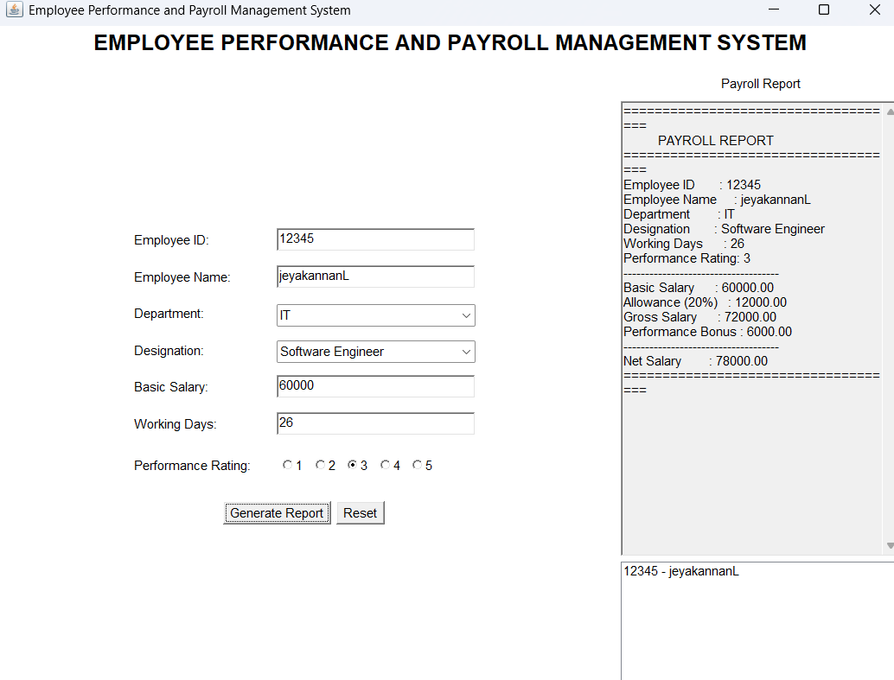
Output Report :
==================================== PAYROLL REPORT
====================================
Employee ID 12345 Employee Name : jeyakannanL Department : IT
Designation : Software Engineer Working Days 26
Performance Rating: 3
Basic Salary : 60000.00

Allowance (20%) : 12000.00 Gross Salary : 72000.00 Performance Bonus : 6000.00
Net Salary : 78000.00

INDUSTRY TASK 2: Online Food Ordering and Billing System
Problem Statement: A restaurant wants to develop a simple Food Ordering and Billing Application for its counter staff. The application should allow customers to select food items, specify quantities, and generate a final bill.

Functional Requirements
- Develop the application using Java AWT.
- Create fields for Customer Name and Table Number.
- Provide Food Category, Food Item, and Quantity selection using appropriate AWT components.
- Provide Add Item, Generate Bill, Clear, Next, and Previous buttons.
- Display selected food items in a List or TextArea.
- Calculate item-wise cost, Subtotal, GST, and Final Bill Amount.
- Implement button click events using ActionListener.
- Use CardLayout to create separate screens for Customer/Order Details, Food Selection, and Bill/Order Summary.
- Validate quantity and ensure that an item is selected before adding it to the order.
Industry Context: The application represents a simplified restaurant POS (Point of Sale) system used for taking customer orders, processing prices, and generating a customer bill.
Output screen shots :

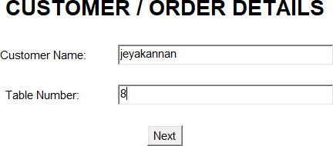

2 . Food selection :

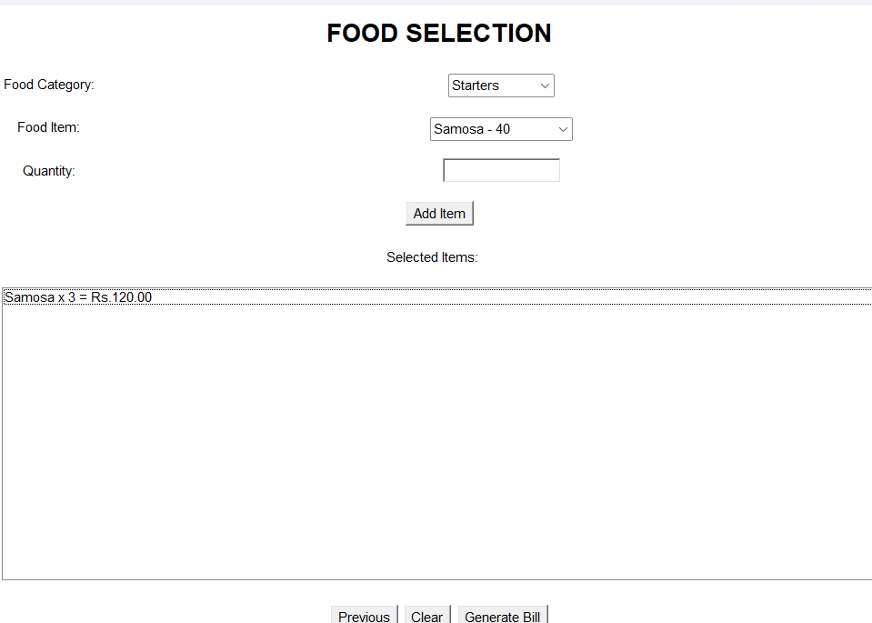
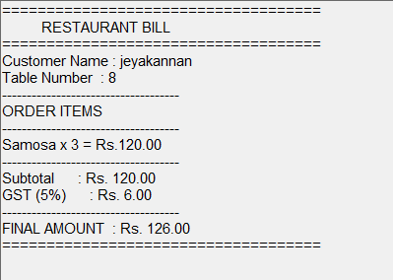

Evaluation Rubric

Criterion | Weightage | Marks / Remarks
Problem Understanding | 15%
GUI Components and Layout | 20%
Event Handling | 20%

Functional Correctness | 25%
Input Validation and User Experience | 10%
Program Explanation / Viva | 10%

